How to Register

- Click “Register Now” or “Register” button.
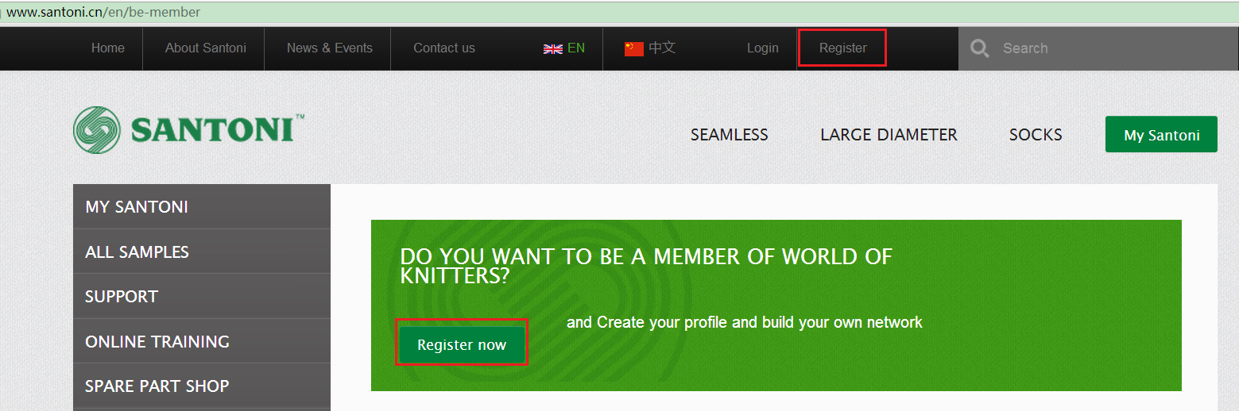

- Then you will go the register page, input the data needed.
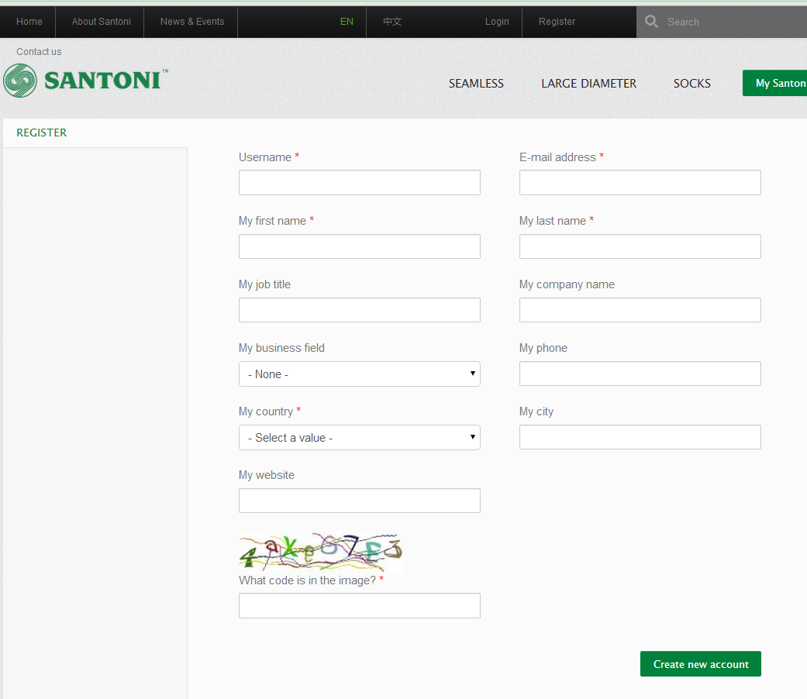

- After click the “create new account” button, it will show message as below picture.
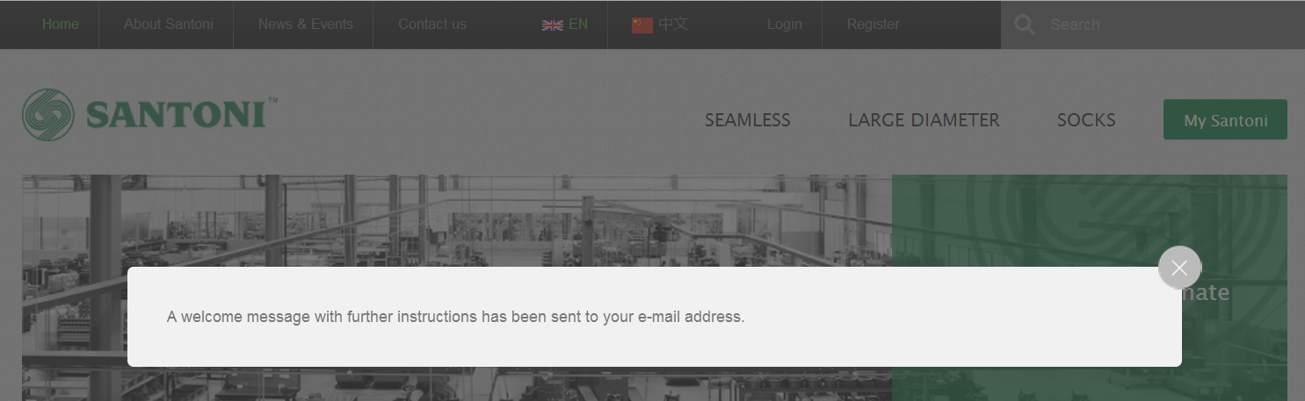

- Log in your email account, you will find an email from Santoni. Click the one-time link to set your password.
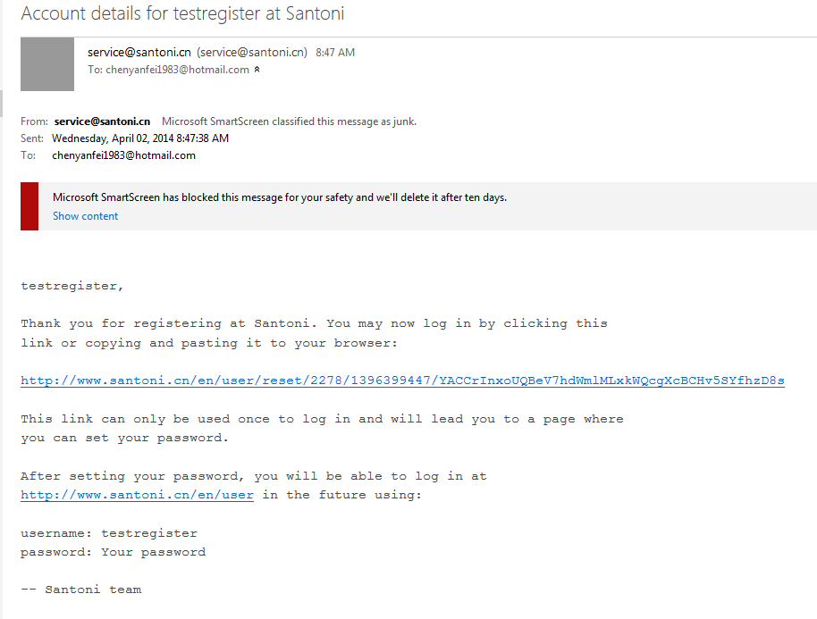

- After setting the password, click “Log in” button.
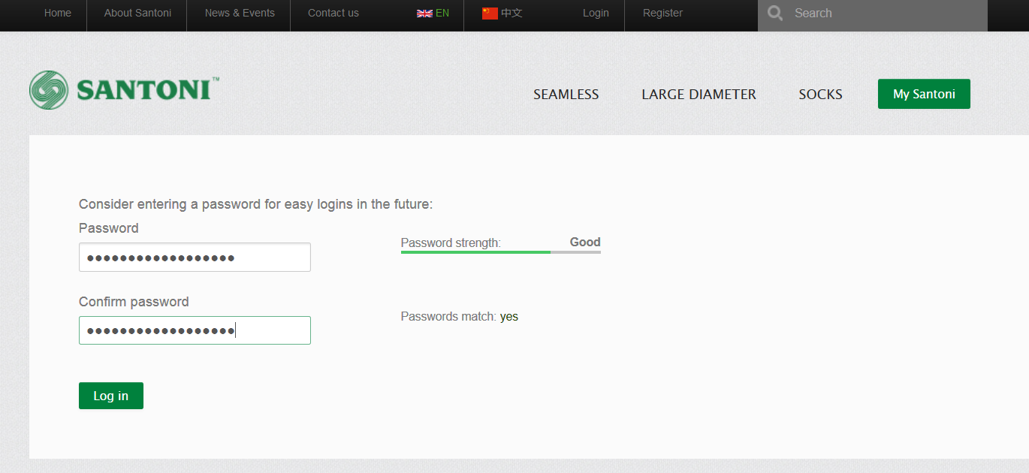

- Then you have successfully registered the account on Santoni website.
